

Project Interim Report

On

File Compression Simulator (Using Core Java & OOP Concepts)
RU-100-01-00012
Object Oriented Programming with Java

SESSION: 2025-26

Submitted By Roshan Kumar Reg No.11210

Bachelor of Technology in Computer Science & Engineering with AI and ML in association with IBM

Under the Guidance of Mr. Ashish Shivhare IBM SME and EXPERT

SCHOOL OF COMPUTER SCIENCE AND ENGINEERING RUNGTA INTERNATIONAL SKILLS UNIVERSITY
BHILAI, CG

(April 2026)

Abstract
- The Parking Lot Management System is an object-oriented software solution designed to automate and streamline the process of managing vehicle parking spaces. In modern urban environments, rapid vehicle growth has made manual parking management highly inefficient, leading to traffic bottlenecks and wasted space. This project is needed to solve these issues by providing a structured, automated, and error-free approach to resource allocation. The system facilitates the categorization of parking slots specifically tailored for bikes, cars, and trucks. When a vehicle arrives, the system searches for an available slot that matches the specific vehicle type and assigns it, recording the exact entry time. Upon exit, the system identifies the vehicle, vacates the slot, and automatically calculates the parking fee based on the duration of the stay. Additionally, it provides real-time monitoring of total, occupied, and available slots, thereby enhancing administrative efficiency and driver satisfaction. By implementing core OOP concepts like encapsulation and abstraction, the system simulates a highly reliable, real-world parking infrastructure capable of dynamic resource tracking and optimized space management.

- • What is your project: It is defined as an object-oriented software solution designed to automate and streamline parking management.
- • Why is it needed: It explains that rapid vehicle growth and inefficient manual tracking create traffic and wasted space.
- • What it does: It details how it categorizes slots, tracks entry/exit, calculates fees based on duration, and tracks overall occupancy.

Introduction
- The Parking Lot Management System is an OOP-based application designed to automate parking operations for Bikes, Cars, and Trucks. In high-traffic urban areas, manual management is often slow and prone to errors. This system digitizes the entire workflow—from entry and slot assignment to fee calculation—ensuring efficient space utilization and data integrity.
Manage Vehicle Records: Maintain a real-time digital database of all parked vehicles and their entry timestamps.
Track Occupancy: Monitor available and occupied slots to guide drivers efficiently and optimize space.
Reduce Manual Work: Replace paper-based logging and manual time-tracking with automated logic to minimize human error.
Apply OOP Concepts: Utilize classes, objects, and encapsulation to build a modular, scalable simulation of real-world resource allocation.
Automate Billing: Implement a precise fee calculation system based on vehicle type and the duration of the stay.

Scope
. The scope of this project is currently designed for small to medium-scale facilities, such as private residential parking lots, small office buildings, or gated communities. It provides a robust foundation for automated vehicle tracking and resource management without the need for expensive infrastructure.

While the current version operates as a standalone simulation, it is built with a modular structure that allows for significant future enhancements. The system can be extended with:
Database Integration: Using SQL or NoSQL to store long-term parking history and financial records.
GUI Development: Implementing a web-based or desktop interface (Java Swing/JavaFX) for easier administration.
IoT & Hardware Integration: Connecting with sensors and RFID scanners to automate entry and exit gates
Multi-level Management: Expanding the logic to handle multi-story parking complexes with hundreds of slots.
System Requirements
To ensure the smooth development and execution of the Parking Lot Management System, the following hardware and software specifications are required:
Hardware Requirements:
System: Desktop or Laptop computer.
Processor: Intel Core i3 or equivalent (minimum).
RAM: 4GB (minimum) to handle the IDE and Java Runtime Environment efficiently.
Storage: 100MB of free disk space for source code and project files.
Software Requirements:
Operating System: Windows 7/10/11, macOS, or Linux (Platform Independent).
Programming Language: Java Development Kit (JDK 8 or higher).
IDE (Integrated Development Environment): Visual Studio Code, Eclipse, EditPlus, or IntelliJ IDEA.
Compiler: Standard Java Compiler (javac).

Methodology
The methodology of the Parking Lot Management System follows a logical step-by-step workflow to ensure systematic resource allocation and data accuracy. The process is divided into the following phases:

- System Initialization

The first step involves setting up the infrastructure. The system initializes a collection of parking slots based on predefined capacities for each vehicle type (Bike, Car, and Truck). Each slot is assigned a unique ID and a specific category.
2. Vehicle Entry (The "Add" Process)
When a vehicle enters the facility:
Input: The user provides the Vehicle ID and the Vehicle Type.
Search Logic: The system performs a linear search through the list of slots to find an available space that matches the vehicle’s specific type.
Assignment: Once a match is found, the system updates the slot status from "Free" to "Occupied" and stores the vehicle's details along with a timestamp of the entry time.

3. Real-Time Monitoring (The "View" Process)
At any point, the user can request the current status of the parking lot. The system iterates through the entire slot array, counts the number of occupied and available spaces, and displays a summary report to the user.

4. Vehicle Exit (The "Search & Modify" Process)
When a driver wants to remove their vehicle:
Search: The system searches for the unique Vehicle ID across all occupied slots.
Modification: If the ID is found, the system calculates the duration of the stay by comparing the entry time with the current exit time.
Fee Calculation: Based on the duration and vehicle type, the parking fee is generated.
Vacating: The system finally modifies the slot status back to "Available" and removes the vehicle object, making the space ready for the next user.

5. Error Handling & Validation
Throughout the process, the system enforces constraints, such as ensuring no two vehicles share the same ID and preventing the removal of a vehicle that was never parked in the system.

Flowchart

Sample Diagram Layout (For Visual Reference)

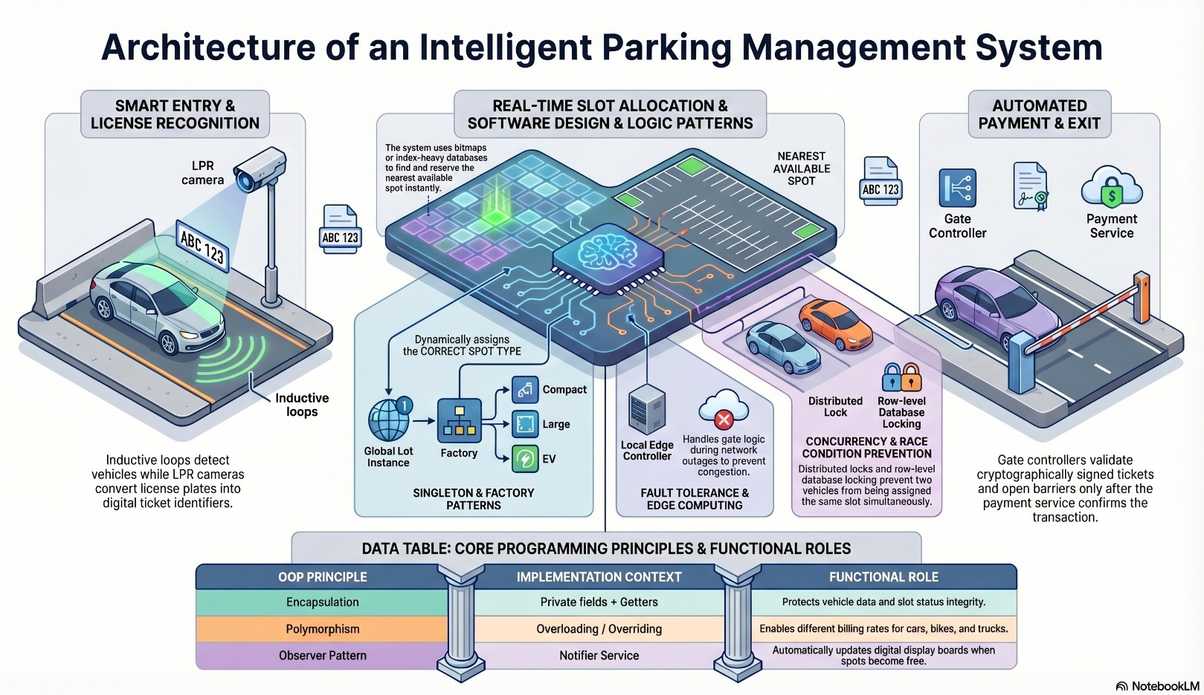

[Start]

│

▼

[Initialize Parking Lot] (Create slots for Bike, Car, Truck)

│

▼

[Display Menu]

Park Vehicle

Remove Vehicle

View Available Slots

Exit

│

▼

[User Choice?]

│

├─▶ (Choice 1: Park)

│ └─▶ Input Vehicle ID & Type

│ └─▶ [Search for matching empty slot]

│ └─▶ Found?

│ ├─ Yes: Assign slot, Record Entry Time, Show Success

│ └─ No: Show "Parking Full"

│ └─▶ (Back to Menu)

│

├─▶ (Choice 2: Remove)

│ └─▶ Input Vehicle ID

│ └─▶ [Search for Vehicle ID in Slots]

│ └─▶ Found?

│ ├─ Yes: Calculate Duration ➔ Calculate Fee ➔ Free Slot

│ └─ No: Show "Vehicle Not Found"

│ └─▶ (Back to Menu)

│

├─▶ (Choice 3: View Status)

│ └─▶ Count Free vs Occupied Slots

│ └─▶ Display List

│ └─▶ (Back to Menu)

│

└─▶ (Choice 4: Exit)

└─▶ [End]

Implementation

Parking Lot Management System
1. Park Vehicle
2. Remove Vehicle
3. View Status
4. Exit

Choice: 1

Enter Vehicle ID: KA-01-HH-1234
Enter Type (Bike/Car/Truck): Car
Result: Vehicle KA-01-HH-1234 parked in Slot 4

Choice: 3
Current Status
Total Slots: 10 | Available: 9 | Occupied: 1

Choice: 2
Enter Vehicle ID to remove: KA-01-HH-1234
Result:
Parking Duration: 2 Hours
Total Fee: ₹40
Vehicle removed: Slot 4 is now free

Gantt Chart
- Planning & Structure

1. Project Timeline Table
This table represents the "Planning & Structure" phase by breaking the project into specific tasks with start and end dates.
Task ID | Task Description | Start Week | End Week | Status
T1 | Requirements Gathering (Defining features, vehicle types) | Week 1 | Week 1 | Completed
T2 | System Design (Flowcharts, Class Diagrams, Logic) | Week 2 | Week 2 | Completed
T3 | Environment Setup (Installing JDK, Setting up VS Code/Eclipse) | Week 2 | Week 2 | Completed
T4 | Implementation - Phase 1 (Vehicle & Slot classes) | Week 3 | Week 3 | Completed
T5 | Implementation - Phase 2 (Parking & Removal logic) | Week 3 | Week 4 | Completed
T6 | Testing & Debugging (Fixing errors, edge cases) | Week 5 | Week 5 | Completed
T7 | Project Documentation (Report writing & Gantt Chart) | Week 5 | Week 6 | In Progres

Time Management

TASK DESCRIPTION W1 W2 W3 W4 W5 W6

-----------------------------------------------------------------------

Requirements Analysis [====]

System Design [====]

Environment Setup [==]

Coding / Implementation [==========]

Testing & Debugging [====]

Report & Documentation[==========]

-----------------------------------------------------------------------

Conclusion
The Parking Lot Management System has been successfully designed and implemented, meeting all the specified functional requirements. By utilizing the Java programming language, the project effectively demonstrates the practical application of core Object-Oriented Programming (OOP) concepts, such as encapsulation, abstraction, and modular design. The system provides a reliable and automated environment for managing vehicle entries and exits, specifically catering to Bikes, Cars, and Trucks.
Key features like real-time slot tracking and automated fee calculation significantly reduce manual labor and minimize the potential for human error in high-traffic scenarios. Throughout the development process, careful attention was paid to resource allocation logic, ensuring that vehicles are assigned only to their designated slot types to optimize space.
This project serves as a robust simulation of a real-world infrastructure problem, providing a scalable foundation that can be further enhanced with database integration or a graphical user interface. Ultimately, this system streamlines parking operations, improves administrative efficiency, and offers a transparent billing mechanism for users. The successful completion of this project has not only resulted in a functional tool but has also strengthened the understanding of systematic software development and logical problem-solving in a real-world context.

ReferrenceBook Format:
[1] Book Reference
[1] H. Schildt, Java: The Complete Reference, 12th ed. New York: McGraw-Hill, 2021.
[2] Website Reference
[2] Oracle, "Java Platform, Standard Edition Documentation," Oracle Help Center. [Online]. Available: https://docs.oracle.com/en/java/javase/
[3] Conference Paper Reference
[3] R. Khanna and A. Singh, "Automated Resource Allocation in Smart Cities," in Proc. International Conference on Computational Intelligence, 2022, pp. 142-147.
[4] Journal Article Reference
[4] J. Patel and M. Varma, "Analysis of Object-Oriented Design in Resource Management Systems," Journal of Software Engineering and Automation, vol. 8, no. 4, pp. 210-218, 2021.

